**CSS Exercise**

**Ex-1: text color**

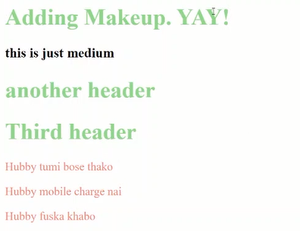

**Ex-2: Background**

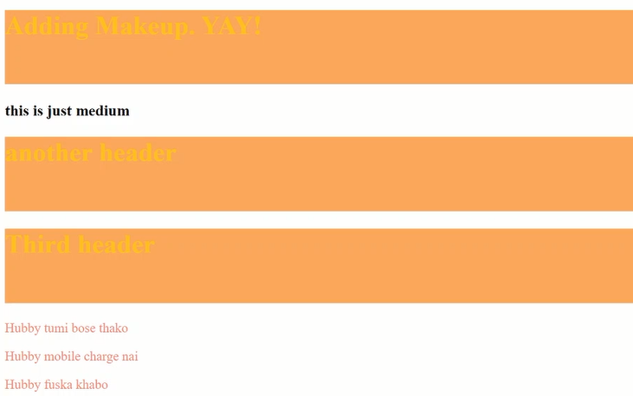

**Ex-3: image**



**Ex-4: font properties**



**Ex-4: id**



**Ex-5: class**

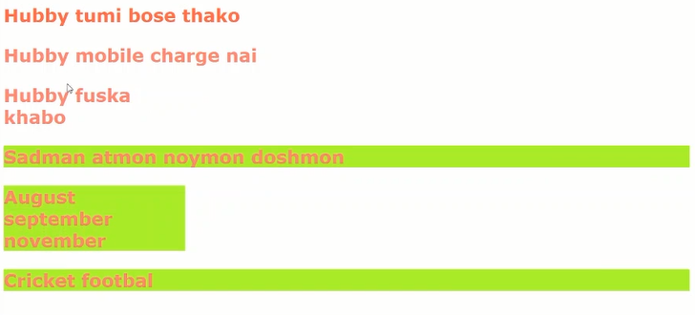

**Ex-6: span**



**Ex-7: div**

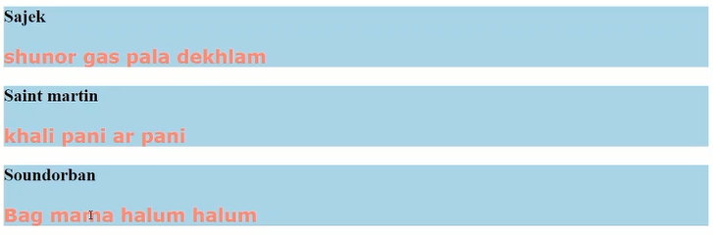

**Ex-8: Border, margin**

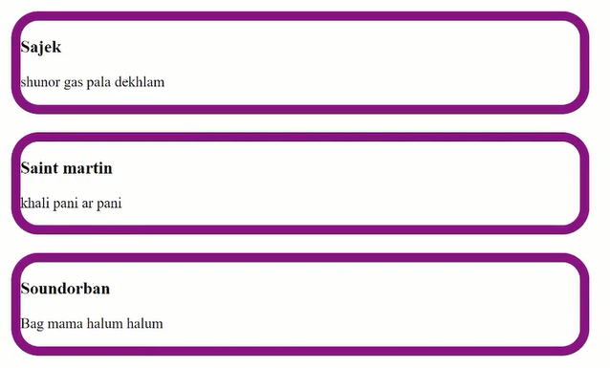

**Ex-9: padding**

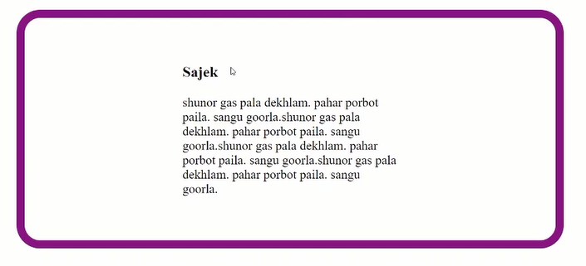

**Ex-10: text-align**

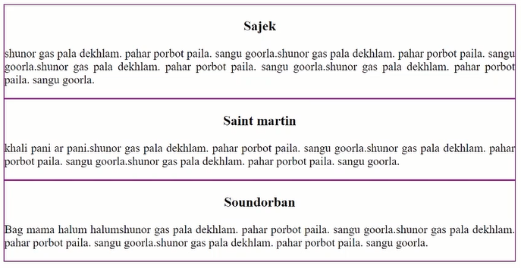

**Ex-11: float/display: inline-block**

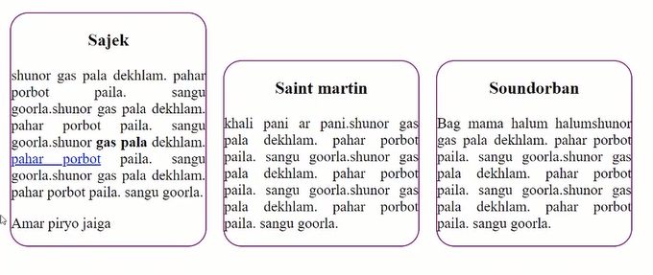

**Ex-12: More design [child class, hover, pseudoclass]**

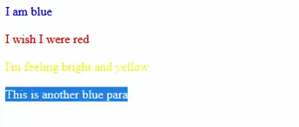

Using ID:

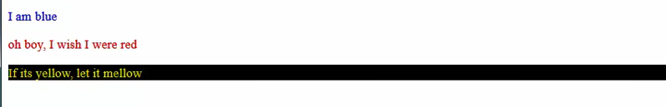

**Border radius**

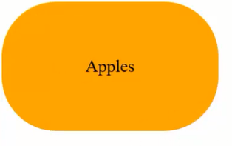

Float property/flex

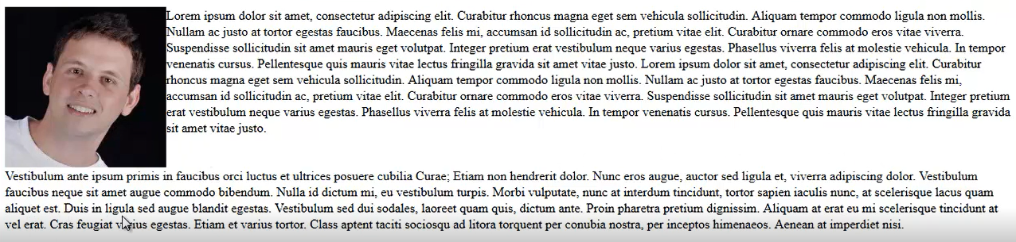

**n-child selectors**

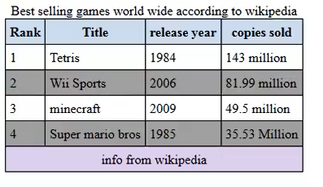

Form design using css

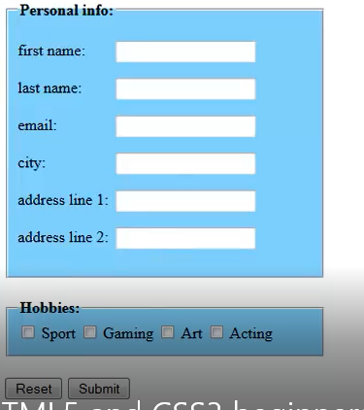

Ex: position sticky/…

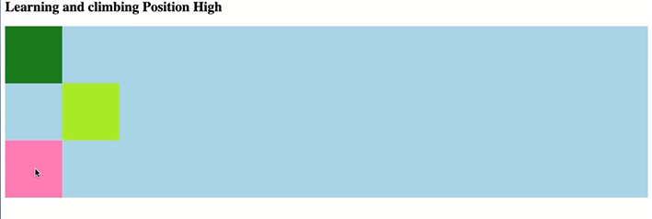

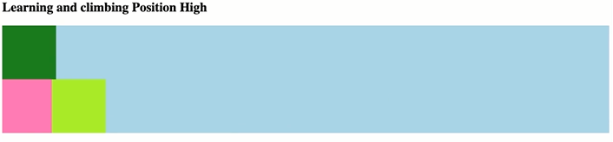

Ex:

